**Servo Motor**

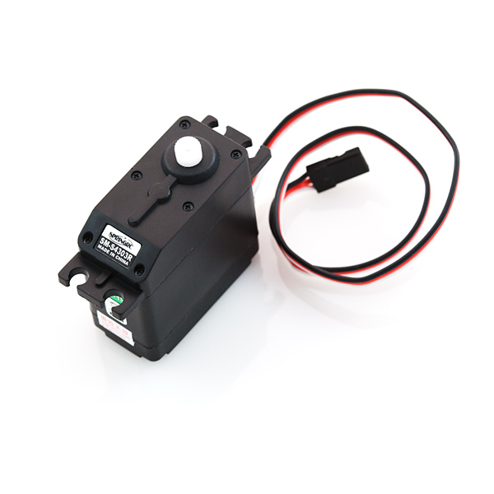

**What It Does:** This servo motor rotates either clockwise or counter clockwise continuously. The motor can be stopped, or allowed to run, for arbitrary amounts of time. Different attachments are available as well.

**Required Connections:** There are three connections that need to be made between the servo and the Arduino. One for power, ground, and another for sending commands to the servo.  
  
Red: add a wire to this connection and attach it to **5V** on the Arduino.  
Black: add a wire to this connection and attach it to **GND/Ground** on the Arduino.  
White: this connection is the signal line for the servo, attach it to either **pin 4 or 7**.

**Using the Servo In Scratch:**

There are two blocks that control the operation of the servo. The *motor* *direction* block and the *motor off* block, both underneath the Motion tab. The *motor direction* block turns on the motor and has it rotate either clockwise or counter-clockwise. This motion continues until a *motor off* block is called.

E:\My Dropbox\PhD\IDSA Workshop\Images\MotorBlock.png

Figure 1: Turn the Motor on Pin 7 Clockwise

E:\My Dropbox\PhD\IDSA Workshop\Images\MotorOff.png

Figure 2: Stopping the Motor on Pin 7

In the example below, the motor attached to pin 7 is rotated in each direction for 5 seconds and then stopped. This action begins whenever the Space Bar is pressed.

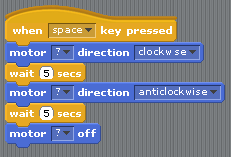

Figure 3: Servo Rotation Example